**Colorant Cycle Count**

*Note: Cycle Counts are not used to correct receiving issues see receiving instructions to correct receiving errors.*

**Go To > Inventory>Physical Inventory Wizard**

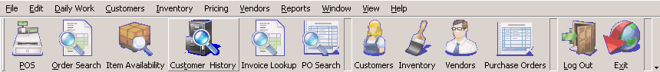

If a count has already been created you will see it in the list.

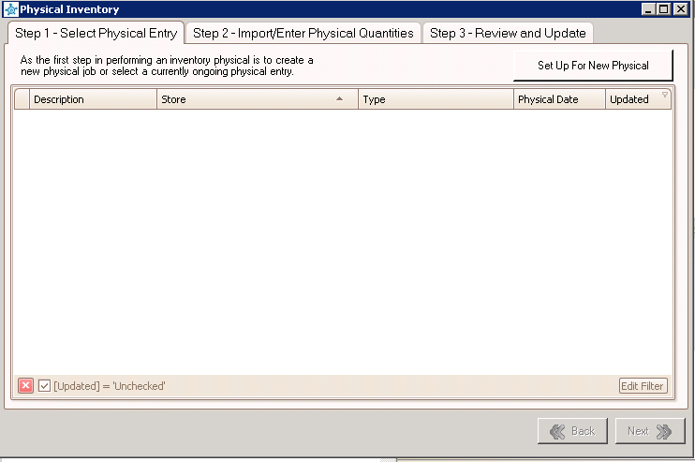

Uncheck (Updated) to see completed cycle counts. Sort, Filter by Store, Physical date etc.

1. **Create a New Colorant Cycle count**

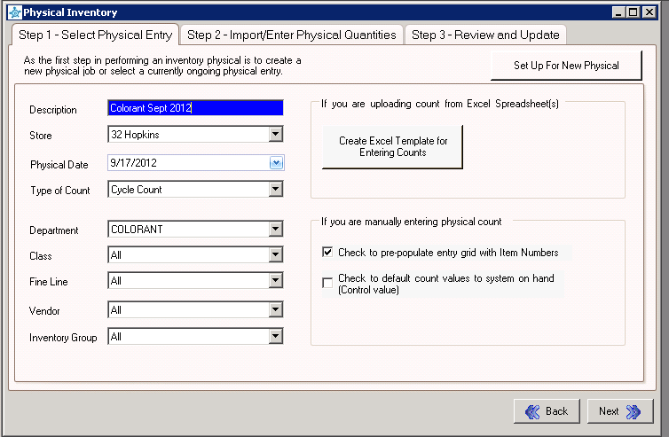

Description should start with Store #, Colorant and month/year

Physical Date: Date you are counting

Type of count = Cycle Count,

Department = Colorant,

Check the box to pre-populate entry grid with Items Number and click “Next”

See **settings in picture** above…Once all settings are entered Click “NEXT”

Notice the plus(+) sign by the description. Click the plus sign and it gives you the cycle count settings. You will need to know these settings to print the cycle count Sheets.

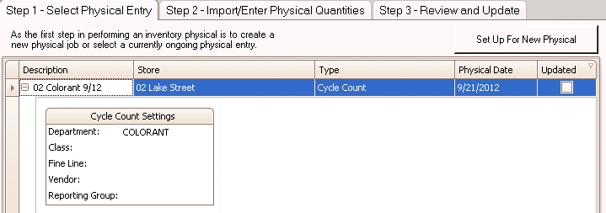

1. **Print Count Sheets**

GoTo> Reports>Report Selector>Inventory>Inventory Count Sheets

Select Show On Hand, Enter Colorant for Department and Sort by Item Number ’Ascending’

Click > Preview

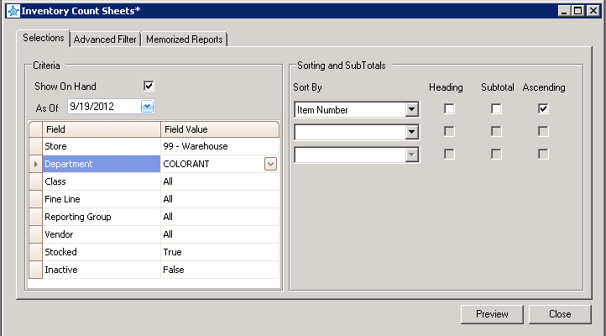

1. **Entering Counts**

Go To > Inventory>Physical Inventory Wizard

Select and Double click the count or highlight and click Next

* Sort by Item and enter your counts.
* ***Note: When entering qty’s “use the down arrow to get to the next qty for easier entry****”* Enter will move the cursor to the Item column.

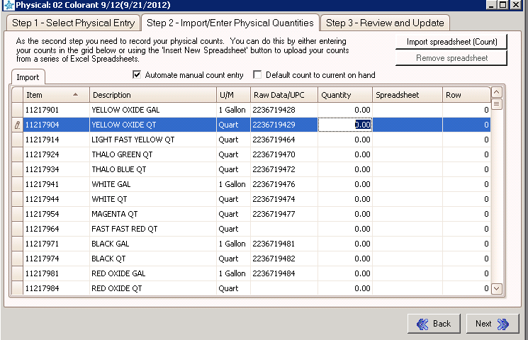

**Uncheck the Default count to current on Hand before going to the Review & Update Tab.**

1. **Review & Update**

When done entering counts Click “NEXT” to Review and Update Counts.

Verify counts and click Update.

**Report for Adjustments**: Reports>Inventory Reports>Inventory Transactions

* Transaction type: physical

